**Choose one of the titles below:  
1. "Physics-Informed Kolmogorov-Arnold Networks for Solving Ordinary Differential Equations with Boundary Constraints"**

**2. "Leveraging Kolmogorov-Arnold Networks for Accurate Function Approximation in Initial Value Problems"**

**3. "A Novel Neural Network Approach for Solving Nonlinear Ordinary Differential Equations"**

**4. "Physics-Guided Neural Network Solutions to Ordinary Differential Equations: A KAN-Based Framework"**

Morteza Farrokhnejad[C:\Users\User\AppData\Local\Microsoft\Windows\INetCache\Content.Word\ORCID-iD_icon_16x16.png](https://orcid.org/0009-0004-6231-2402), Ali Farrokhnejad[C:\Users\User\AppData\Local\Microsoft\Windows\INetCache\Content.Word\ORCID-iD_icon_16x16.png](https://orcid.org/my-orcid?orcid=0009-0008-0749-3377), Ahmet Rizaner



Department of Information Technology, School of Computing and Technology, Eastern Mediterranean University, 99628, Famagusta, North Cyprus, via Mersin 10, Turkey

ARTICLE INFO

-----------------------------

Keywords: Kolmogorov-Arnold Networks (KAN), Ordinary Differential Equations (ODEs), Function Approximation, Neural Network Architectures, Computational Mathematics, Machine Learning in Mathematical Modeling

**Choose the corresponding author**

**Abstract**

Ordinary Differential Equations (ODEs) are fundamental in modeling various scientific and engineering systems, yet their solution is often computationally challenging, particularly when closed-form solutions are unavailable. Traditional numerical methods such as Runge-Kutta and finite differences have been employed, but they come with limitations in efficiency and computational cost. This paper explores the use of the Kolmogorov-Arnold Network (KAN) for the numerical resolution of first-order ODEs, an emerging architecture based on the Kolmogorov-Arnold theorem. The KAN's unique approach to function approximation, using a decomposition of multivariate functions into univariate components, allows for high precision with fewer parameters and faster convergence than traditional neural networks like Radial Basis Function Neural Networks (RBFNNs) and Wavelet Neural Networks (WNNs). The efficacy of the KAN model is demonstrated through comparison with other methods on example ODEs, showing comparable, if not superior accuracy. The findings suggest that KAN presents a promising alternative for solving complex ODEs, offering enhanced computational efficiency and robustness over traditional techniques and other neural network models.

1. **Introduction**

Ordinary Differential Equations (ODEs) serve as fundamental instruments in the mathematical modeling and analytical study of numerous scientific and engineering systems. They naturally emerge in diverse applications, including but not limited to fluid dynamics, chemical reaction kinetics, population dynamics, and structural analysis [1-5, 13, 19, 20]. The inherent complexity of ODEs presents significant challenges in their solution, as numerous cases do not yield closed-form solutions, necessitating the utilization of numerical or approximation techniques. Established numerical methodologies, including the Runge-Kutta technique, finite difference approach, and shooting method, have historically been employed to tackle these challenges. However, their drawbacks, such as considerable computational demands and the inability to produce closed-form solutions have motivated the investigation of alternative strategies for ODE resolution [1-3, 5, 12, 13, 19, 20].

The introduction of Artificial Neural Networks (ANNs) has facilitated novel methodologies for the numerical resolution of ODEs by recontextualizing the problem as an optimization framework. Preliminary investigations have demonstrated the efficacy of Multilayer Perceptrons (MLPs) in approximating solutions to both Initial Value Problems (IVPs) and Boundary Value Problems (BVPs).

These methods based on neural networks are much more efficient than the classical numerical techniques. In particular, ANNs are capable of formulating analytic solutions which eliminate the necessity for performing interpolation over discretized computational intervals, hence more flexibility in solving IVPs and BVPs [1, 3, 6, 7, 11, 13 -17, 20]. On the other hand, the first generation of models based on ANNs had several challenges [19] among which were the pronounced vulnerability to convergence at local minima and suboptimal rates of convergence [1]. Merge two paragraphs above

As a solution to the shortcomings of the ANNs mentioned, new generation advanced architectures such as Radial Basis Function Neural Networks(RBFNNs) [2, 3, 12] and Wavelet Neural Networks (WNNs) [1, 19, 20] have emerged. These approaches have been recorded to have shorter convergence times and a higher accuracy compared to traditional techniques when applied to complex expressions of differential equations. Furthermore, WNNs have attracted considerable interest because their activation functions are concentrated so that the size of the network can be kept small which allows faster training while preserving the ability of any approximation that is said to be achieved by neural networks [1, 20]. Furthermore, the implementation of sophisticated training methodologies, such as Extreme Learning Machines (ELM) and metaheuristic optimization techniques, including Particle Swarm Optimization (PSO), has substantially enhanced both the efficiency and accuracy of these neural network models [1, 2, 4, 5, 14].

In response to this assertion, the Kolmogorov-Arnold Network (KAN) architecture evolves a novel architecture which is robust and function approximation, which shows potential for solving ODEs. ODEs are appreciably accounted for in this architecture. The KAN model is based on the Kolmogorov-Arnold representation theorem which states that every multivariate continuous function can be expressed as a finite sum of univariate functions [6-8, 13, 15-18]. This inbuilt universality renders KAN particularly adept at approximating intricate mathematical models, including those characterized by ODEs [6, 7, 13, 16-18]. By capitalizing on KAN’s systematic approach to function decomposition.

This paper attempts to use KAN’s systematic functioning on KAN as a function decomposition architecture on neural networks to overcome the shortcomings that are posed by the current neural network architectures on differential equations. The primary aim of the study is to make use of the KAN architecture for the approximation of the solutions of first order ODEs. This investigation is a major breakthrough in the fusion of sophisticated machine learning techniques with computational mathematics. The ANN-based approach is contrasted to the KAN structure, which is able to build a process-specific problem space and in this way improve the approximation of the results [17, 18]. It is also different from any other design in that the network can become more precise with a decrease in the number of parameters, which in turn makes it relatively faster while preserving the accuracy [6, 7 ,13 ,15 ,17 ,18].  
The rationale behind the implementation of KAN in this framework is the existed capabilities to handle the critical ODEs solution. Mostly, first order ODEs are noted to be not serious with the many complicated boundary conditions. However, they may now and then show some anomalously typical of nonlinear dynamics which affects the conventional numeric technique [ 7, 8, 13, 17, 18]. The unique modification of KAN, characteristic of the agility of the system to the situation, along with an expressive mode of representation of the mentioned challenges, definitely leads to very good results in their solution. Furthermore, KAN can be easily upgraded by including advanced optimization algorithms [18], hence it is enhanced in solving ODEs with its robustness.  
Recent investigations emphasize the efficacy of neural network architectures in the resolution of differential equations. Specifically, WNNs, when enhanced through sophisticated optimization techniques such as the butterfly optimization algorithm, exhibit superior capabilities in approximating solutions to ODEs. [1, 20]. Moreover, RBFNNs trained via extreme learning methodologies demonstrate the high rates of convergence and high accuracy regarding fractional differential equations [2, 3, 12]. These discoveries demonstrate the resurgence and importance of neural network models in computational mathematics.

Notwithstanding the advancements made in this field, significant deficiencies persist in the literature concerning the application of KAN to ODEs. Although the Kolmogorov-Arnold Theorem (KAT) offers a theoretical framework for function approximation [15 - 18], its practical deployment for the resolution of ODEs remains insufficiently investigated. This research endeavors to fill this lacuna by executing a thorough assessment of KAN's effectiveness in solving first-order ODEs. Through methodical experimentation, this study aims to validate KAN as a robust and efficient methodology for function approximation specifically within the context of differential equations.

The implications of this research transcend the direct utilization of KAN in the context of ODEs. By establishing its efficacy as a versatile function approximator, this investigation enriches the field of computational mathematics and neural network-based modeling. The findings derived from this study are anticipated to guide the advancement of next-generation computational methodologies adept at solving intricate scientific and engineering challenges, consequently, the KAN constitutes a significant progression in the application of machine learning techniques for the resolution of differential equations. Its distinctive architectural framework and theoretical foundations establish it as a formidable alternative to prevailing ANN methodologies for function approximation. This research aims to enhance the current capabilities of neural network-based approaches in addressing first-order ODEs by leveraging KAN, thereby facilitating advancements in computational mathematics and related fields.

**Write the organization of the paper here when the content structure is clear.**

1. **Kolmogorov-Arnold Model**

The KAN model is optimally configured for function approximation tasks [15 - 18], including the resolution of ODEs, owing to its basis in the KAT. This theorem asserts that any continuous multivariate function can be expressed as a finite summation of univariate functions subjected to linear operations, thereby facilitating the ability of a KAN to approximate intricate functions with reduced network depth [6, 7, 13, 15 - 18]. By utilizing this property, KANs inherently diminish the computational complexity associated with multivariate functions while preserving accuracy, [6 - 8, 13, 17, 18] a critical factor for accurately modeling the complex dynamics of ODEs. KANs are architected to optimize the advantages of the KAT by structuring layers such that univariate basis functions are hierarchically composed [15, 17, 18], resulting in outputs that effectively approximate multivariate functions. In contrast to conventional MLPs, which depend on universal approximation via dense layers and nonlinear activation functions, KANs leverage the structural organization offered by KAT to attain efficient and precise function representations [6 - 8, 13 ,15 - 18]. The hidden layers of the network typically utilize Gaussian Radial Basis Functions (RBFs) as activation functions, selected for their smoothness properties and capacity for spatial localization of approximations [13, 17, 18]. These RBFs facilitate a concentration of response from each hidden layer neuron to distinct regions of the input space, which is essential for the accurate resolution of ODEs where localized dynamics predominantly influence system behavior. In contrast to WNNs, which employ wavelet transformations to achieve a compact topology and facilitate efficient training, KANs present an alternative framework founded on the theoretical assurances provided by the KAT [17, 18]. While both WNNs and RBF networks demonstrate proficiency in distinct application domains [1, 2, 3, 12], the hierarchical univariate decomposition characteristic of KANs is inherently more compatible with the requirements associated with ODE approximation [13]. This congruence enables KANs to deliver accurate gradient evaluations, a feature that is particularly beneficial for integration with differentiable ODE solvers. These solvers exploit the structured outputs of KANs to simulate dynamical systems and extract latent physical phenomena while incurring minimal computational overhead.

A notable advantage of utilizing KANs is their ability to process high-dimensional input data effectively. The application of the superposition principle within KAT mitigates the complexity associated with high dimensionality by decomposing intricate functions into simpler, constituent components. This decomposition enhances model interpretability and streamlines the training process, as the optimization burden is reduced due to a smaller number of parameters relative to fully interconnected neural networks [6 - 8, 13 ,15 – 18]. Additionally, the modular architecture of KANs supports their integration into hybrid systems [18], including Neural ODEs, where KANs function as gradient evaluators to iteratively optimize solutions to ODEs.

KANs utilize univariate function composition, which results in high convergence efficiency [6, 7, 8, 13, 17, 18]. The univariate basis functions are designed to capture distinct characteristics of the input, facilitating expedited learning and mitigating overfitting [17, 18]. This attribute is especially critical in addressing ODEs, where the solution landscape may present abrupt gradients or localized features. By integrating domain-specific insights into the selection of basis functions, such as Gaussian RBFs or B-splines, KANs demonstrate enhanced efficacy in approximating solutions to complex differential equations relative to alternative neural network frameworks, therefore, the KAN model serves as a powerful tool for tasks such as solving ODEs. Its theoretical foundation, coupled with its efficient architectural design and adaptability to high-dimensional parameter spaces, positions it as a superior alternative to conventional neural network paradigms. By decomposing multivariate functions into their univariate components, KANs enhance computational efficiency and exhibit strong approximation properties, thereby aligning optimally with the requirements of contemporary ODE-solving techniques.

1. **Methodology of Solving ODEs using KAN**

**3.1. Trial Solution Approach to Solving Differential Equations**

The trial solution methodology is a crucial step in the neural network-based approximation of differential equations. The general first-order differential equation is represented as:

With being the initial condition.

From there, the differential equation is now an initial value problem (IVP) and a trial solution can be constructed by considering the values from the initial condition, as such:

Here, is the output of the KAN model.

The error used to train the KAN model can be defined as such:

Finally, the new weights can be calculated using the error defined above:

**3.2. Architectural Representation of KAN**

Figure of KAN and explanation

1. **Numerical Examples**

In this section, some example equations are evaluated by the KAN model. The results are then compared to other similar approaches.

* 1. **Example 1**

Consider the following first-order differential equation:

With the initial condition:

Compared results to other references:

| **x** | **Exact solution** | **Euler** | **RungeKutta** | **RBFNet (n=9) [3]** | **KAN** | **RBFNN (n=9) [2]** |  |
| --- | --- | --- | --- | --- | --- | --- | --- |
| 0.00 | 1.0000 | 1.0000 | 1.0000 | 1.0000 | 1.0000 | 1.0000 |  |
| 0.05 | 0.9536 | 0.9500 | 0.9536 | 0.9536 | 0.9535 | 0.9536 |  |
| 0.10 | 0.9137 | 0.9072 | 0.9138 | 0.9137 | 0.9137 | 0.9137 |  |
| 0.15 | 0.8798 | 0.8707 | 0.8799 | 0.8798 | 0.8798 | 0.8798 |  |
| 0.20 | 0.8514 | 0.8401 | 0.8515 | 0.8514 | 0.8514 | 0.8514 |  |
| 0.25 | 0.8283 | 0.8150 | 0.8283 | 0.8283 | 0.8283 | 0.8283 |  |
| 0.30 | 0.8104 | 0.7953 | 0.8105 | 0.8104 | 0.8104 | 0.8104 |  |
| 0.35 | 0.7978 | 0.7810 | 0.7979 | 0.7978 | 0.7977 | 0.7978 |  |
| 0.40 | 0.7905 | 0.7721 | 0.7907 | 0.7905 | 0.7905 | 0.7905 |  |
| 0.45 | 0.7889 | 0.7689 | 0.7890 | 0.7889 | 0.7888 | 0.7889 |  |
| 0.50 | 0.7931 | 0.7717 | 0.7932 | 0.7930 | 0.7930 | 0.7931 |  |
| 0.55 | 0.8033 | 0.7805 | 0.8035 | 0.8033 | 0.8033 | 0.8033 |  |
| 0.60 | 0.8200 | 0.7958 | 0.8201 | 0.8199 | 0.8199 | 0.8200 |  |
| 0.65 | 0.8431 | 0.8178 | 0.8433 | 0.8431 | 0.8431 | 0.8431 |  |
| 0.70 | 0.8731 | 0.8467 | 0.8733 | 0.8731 | 0.8731 | 0.8731 |  |
| 0.75 | 0.9101 | 0.8826 | 0.9102 | 0.9100 | 0.9100 | 0.9101 |  |
| 0.80 | 0.9541 | 0.9258 | 0.9542 | 0.9540 | 0.9540 | 0.9541 |  |
| 0.85 | 1.0053 | 0.9763 | 1.0054 | 1.0052 | 1.0052 | 1.0053 |  |
| 0.90 | 1.0637 | 1.0342 | 1.0638 | 1.0637 | 1.0637 | 1.0637 |  |
| 0.95 | 1.1293 | 1.0995 | 1.1294 | 1.1293 | 1.1293 | 1.1293 |  |
| 1.00 | 1.2022 | 1.1721 | 1.2022 | 1.2021 | 1.2021 | 1.2022 |  |
| **MSE** | 0 | 4.60e-04 | 1.24e-08 | 6.80e-10 | 4.66e-11 | 7.56e-14 |  |

Table 1. Comparison of MSE Values from References with KAN MSE for Example 1

**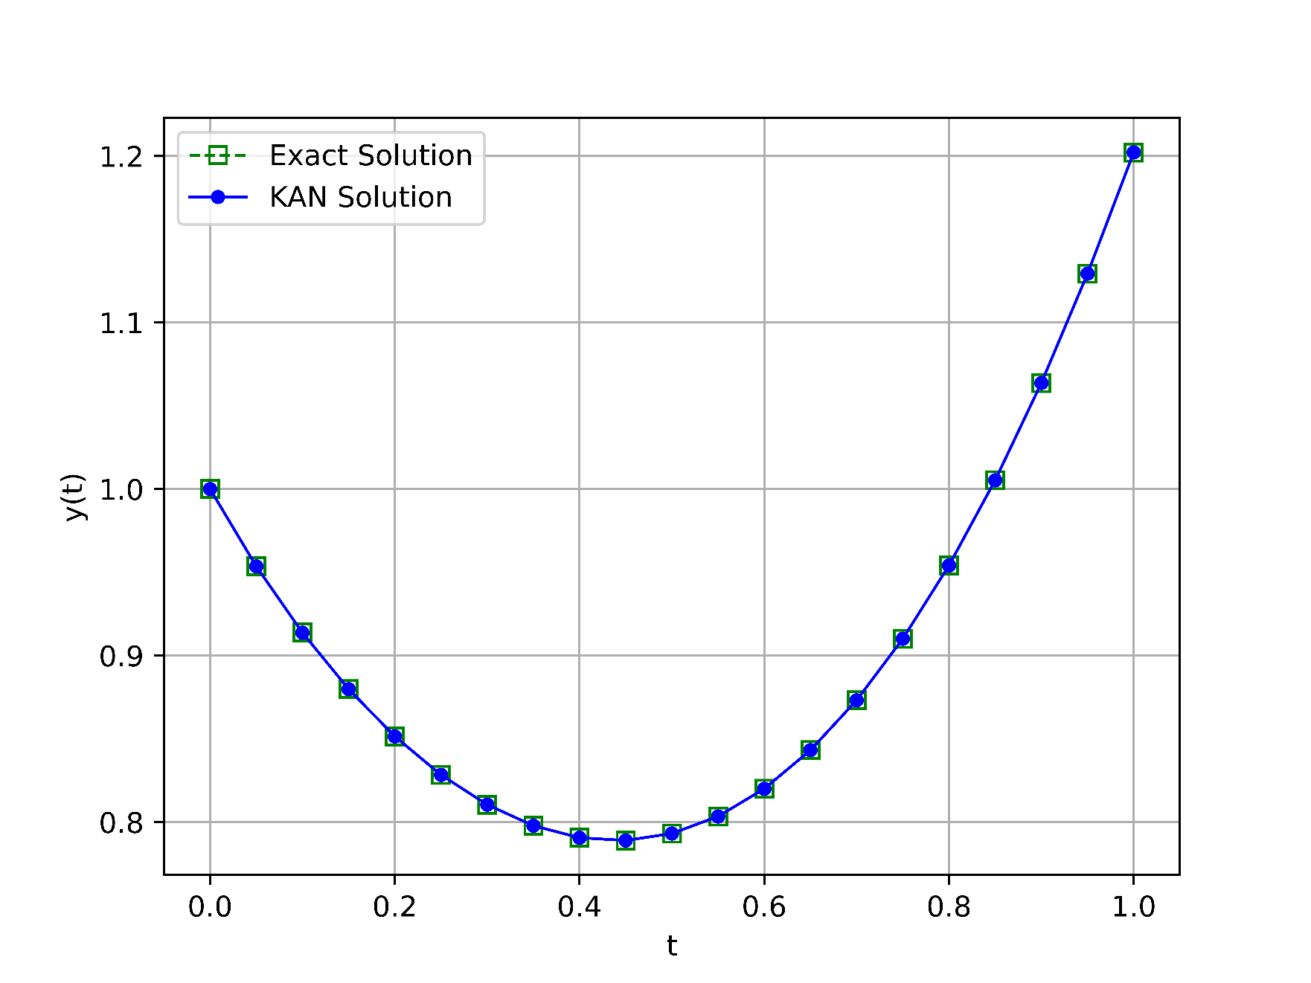**The results in Table 1 demonstrate the superior accuracy of the KAN model compared to other numerical methods and neural network architectures. Notably, the Mean Squared Error (MSE) of the KAN model is the lowest among all methods, including RBFNet and RBFNN. This highlights KAN's ability to closely approximate the exact solution with minimal error across the entire domain. Furthermore, KAN maintains consistency and accuracy even in regions where other models exhibit noticeable deviations from the exact solution. These findings underscore the robustness of KAN in solving first-order differential equations with high precision.

Figure 1. Exact and KAN Solution Comparison for Example 1

* 1. **Example 2**

Consider another first-order linear differential equation:

With the initial condition:

Compared results to other references:

| **x** | **WNNIBOA [1]** | **WNNBOA [1]** | **WNNPSO [1]** | **WNNPSOA [1]** | **WNNMBP [1]** | **WNNDEV [1]** | **RBFNs [3]** | **KAN** |
| --- | --- | --- | --- | --- | --- | --- | --- | --- |
| 0.00 | 0 | 0 | 0 | 0 | 0 | 0 | 0 | 0 |
| 0.15 | 1.94e-07 | 3.83e-01 | 4.26e-03 | 3.96e-03 | 6.06e-03 | 2.06e-01 | 3.35e-04 | 1.02e-04 |
| 0.30 | 1.14e-07 | 4.91e-01 | 8.61e-03 | 8.60e-03 | 1.37e-02 | 2.78e-01 | 3.97e-04 | 7.78e-05 |
| 0.45 | 9.81e-08 | 4.55e-01 | 4.31e-03 | 4.78e-03 | 8.48e-03 | 9.93e-02 | 1.01e-04 | 6.29e-05 |
| 0.60 | 6.96e-08 | 3.72e-01 | 1.37e-03 | 7.14e-04 | 7.51e-04 | 3.56e-02 | 4.16e-04 | 4.82e-05 |
| 0.75 | 4.66e-08 | 3.07e-01 | 2.33e-03 | 2.00e-03 | 4.37e-03 | 3.90e-02 | 1.10e-03 | 4.25e-05 |
| 0.90 | 3.22e-08 | 2.89e-01 | 8.68e-04 | 4.93e-04 | 1.09e-03 | 2.33e-01 | 1.39e-03 | 3.53e-05 |
| 1.05 | 2.35e-08 | 3.18e-01 | 3.74e-03 | 2.90e-03 | 4.05e-03 | 3.49e-01 | 9.82e-04 | 9.93e-06 |
| 1.20 | 2.71e-08 | 3.74e-01 | 3.21e-03 | 2.65e-03 | 5.86e-03 | 2.80e-01 | 5.99e-04 | 8.43e-06 |
| 1.35 | 3.27e-08 | 4.27e-01 | 1.09e-04 | 4.75e-04 | 3.18e-03 | 8.31e-02 | 8.12e-04 | 6.32e-05 |
| 1.50 | 3.05e-08 | 4.48e-01 | 2.34e-03 | 1.22e-03 | 1.17e-03 | 8.79e-02 | 1.12e-03 | 3.67e-05 |
| 1.65 | 2.46e-08 | 4.20e-01 | 1.94e-03 | 1.06e-03 | 3.50e-03 | 1.25e-01 | 1.09e-03 | 6.43e-06 |
| 1.80 | 1.66e-08 | 3.48e-01 | 4.95e-04 | 2.19e-04 | 2.37e-03 | 4.67e-02 | 6.07e-04 | 8.22e-06 |
| 1.95 | 5.45e-09 | 2.54e-01 | 2.22e-03 | 1.01e-03 | 7.16e-04 | 3.59e-02 | 1.06e-04 | 4.58e-06 |
| 2.10 | 4.24e-10 | 1.74e-01 | 1.46e-03 | 6.39e-04 | 2.95e-03 | 2.95e-02 | 2.78e-04 | 4.70e-06 |
| 2.25 | 1.37e-09 | 1.42e-01 | 7.81e-04 | 1.47e-04 | 2.55e-03 | 5.14e-02 | 8.27e-04 | 1.03e-05 |
| 2.40 | 1.17e-08 | 1.87e-01 | 1.78e-03 | 3.94e-04 | 2.58e-05 | 1.04e-01 | 1.23e-03 | 1.67e-05 |
| 2.55 | 1.30e-08 | 3.23e-01 | 2.82e-04 | 1.18e-04 | 2.30e-03 | 5.27e-02 | 1.48e-03 | 2.37e-05 |
| 2.70 | 2.57e-09 | 5.54e-01 | 1.53e-03 | 8.06e-06 | 2.05e-03 | 4.40e-02 | 1.78e-03 | 6.30e-06 |
| 2.85 | 2.61e-08 | 8.80e-01 | 4.11e-04 | 3.69e-05 | 9.74e-04 | 5.01e-02 | 2.49e-03 | 1.83e-06 |
| 3.00 | 9.59e-08 | 1.31e+00 | 1.45e-03 | 1.24e-04 | 2.23e-03 | 2.43e-03 | 2.86e-03 | 9.76e-05 |
| **MAE** | 4.12e-08 | 4.03e-01 | 2.07e-03 | 1.50e-03 | 3.26e-03 | 1.06e-01 | 9.52e-04 | 3.34e-06 |

Table 2. Comparison of MAE Values from References with KAN MAE for Example 2

| **x** | **Exact Solution** | **RBFNet (n=21) [3]** | **RBFNN (n=21) [2]** | **RBFNN (n=90) [2]** | **KAN** |
| --- | --- | --- | --- | --- | --- |
| 0.00 | 3.0000 | 3.0000 | 3.0000 | 3.0000 | 3.000 |
| 0.15 | 2.3438 | 2.2435 | 2.3438 | 2.3438 | 2.3437 |
| 0.30 | 1.8142 | 1.8138 | 1.8142 | 1.8142 | 1.8141 |
| 0.45 | 1.3511 | 1.3510 | 1.3511 | 1.3511 | 1.3511 |
| 0.60 | 0.9348 | 0.9344 | 0.9348 | 0.9348 | 0.9347 |
| 0.75 | 0.5763 | 0.5752 | 0.5763 | 0.5763 | 0.5762 |
| 0.90 | 0.3012 | 0.2998 | 0.3012 | 0.3012 | 0.3011 |
| 1.05 | 0.1318 | 0.1308 | 0.1318 | 0.1318 | 0.1317 |
| 1.20 | 0.0726 | 0.0720 | 0.0726 | 0.0726 | 0.0725 |
| 1.35 | 0.1038 | 0.1030 | 0.1038 | 0.1038 | 0.1038 |
| 1.50 | 0.1845 | 0.1834 | 0.1845 | 0.1845 | 0.1844 |
| 1.65 | 0.2643 | 0.2632 | 0.2643 | 0.2643 | 0.2642 |
| 1.80 | 0.2988 | 0.2982 | 0.2988 | 0.2988 | 0.2988 |
| 1.95 | 0.2638 | 0.2637 | 0.2638 | 0.2638 | 0.2638 |
| 2.10 | 0.1625 | 0.1622 | 0.1625 | 0.1625 | 0.1624 |
| 2.25 | 0.0235 | 0.02227 | 0.0235 | 0.0235 | 0.0235 |
| 2.40 | -0.1095 | -0.1107 | -0.1095 | -0.1095 | -0.1094 |
| 2.55 | -0.1937 | -0.1952 | -0.1937 | -0.1937 | -0.1936 |
| 2.70 | -0.2025 | -0.2043 | -0.2025 | -0.2025 | -0.2025 |
| 2.85 | -0.1348 | -0.1373 | -0.1348 | -0.1348 | -0.1348 |
| 3.00 | -0.0157 | -0.0186 | -0.0157 | -0.0157 | -0.0156 |
| **Error** | 0 | 1.44e-06 | 5.85e-12 | 9.95e-13 | 2.10e-10 |

Table 3. Comparison of MSE Values from References with KAN MSE for Example 2

The comparison in Table 2 highlights the exceptional performance of the KAN model in approximating the solution of the given differential equation. KAN achieves the smallest Mean Absolute Error (MAE) among all tested methods, including WNN variants and RBFNs. Unlike other methods, which show variability in error rates across different intervals, KAN provides consistently low errors throughout the domain. This demonstrates KAN's effectiveness in managing complex solution landscapes while maintaining computational efficiency and accuracy.

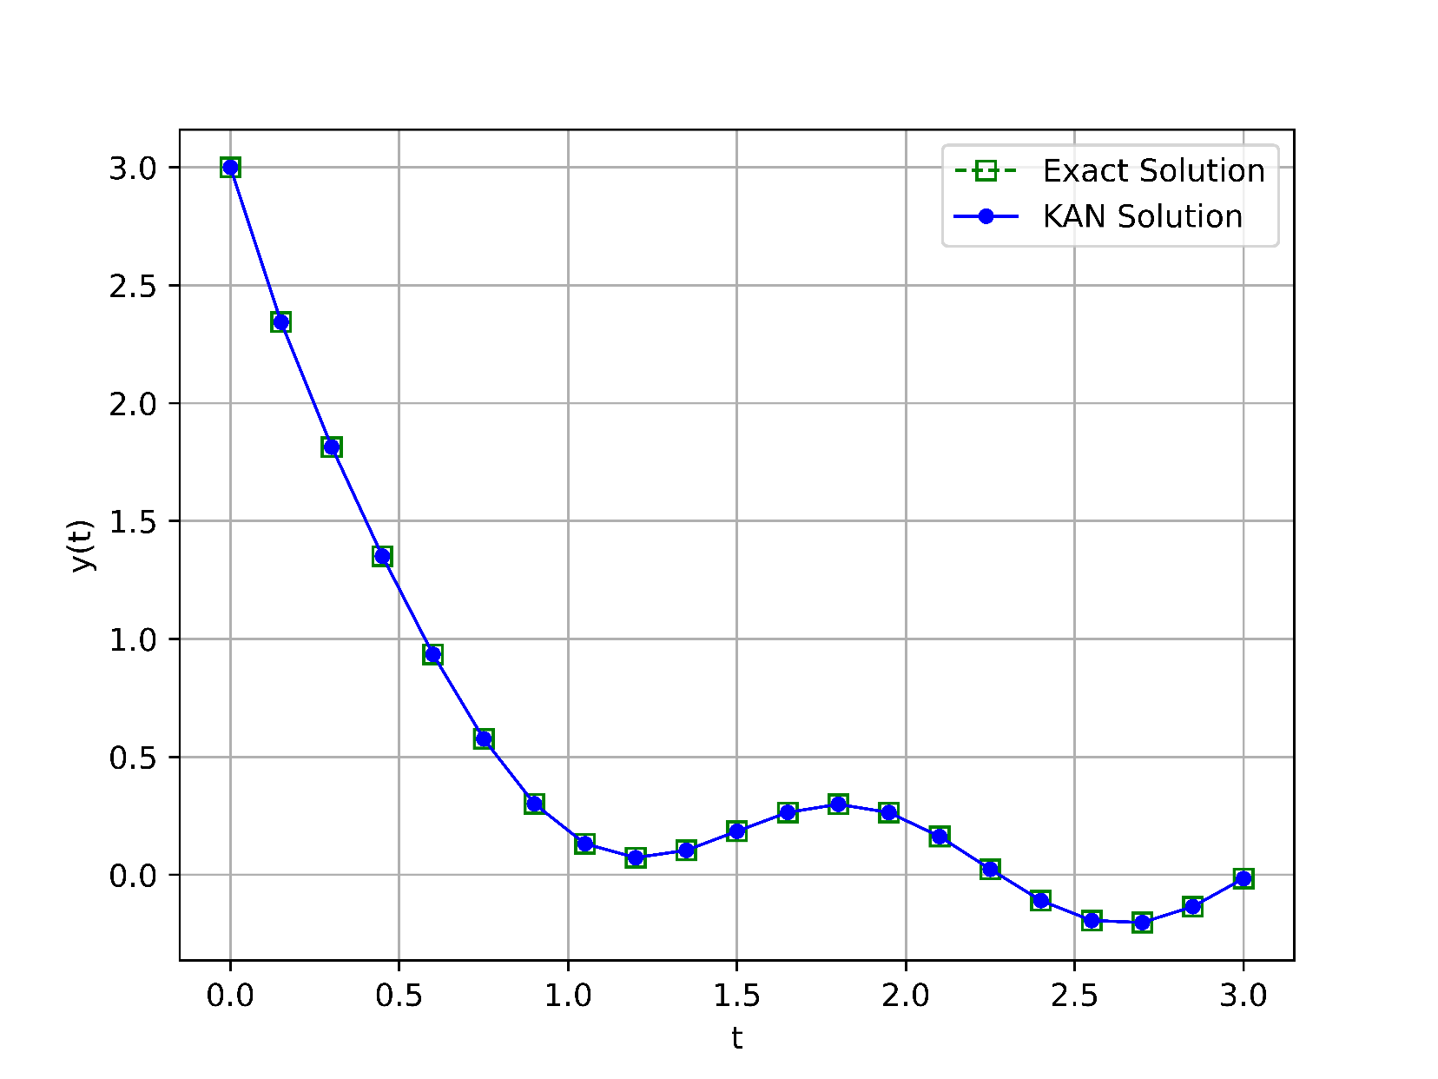

Figure 2. Exact and KAN Solution Comparison for Example 2

* 1. **Example 3**

Consider another first-order linear differential equation:

With the initial condition:

Compared results to other references:

| **x** | **WNNIBOA [1]** | **WNNBOA [1]** | **WNNPSO [1]** | **WNNPSOA [1]** | **WNNMBP [1]** | **WNNDEV [1]** | **PSNNs [19]** | **CNNs [19]** | **Heun [19]** | **KAN** |
| --- | --- | --- | --- | --- | --- | --- | --- | --- | --- | --- |
| 0.0000 | 0 | 0 | 0 | 0 | 0 | 0 | 0 | 0 | 0 | 0 |
| 0.2000 | 3.72e-09 | 1.54e-01 | 5.05e-05 | 1.64e-04 | 4.73e-04 | 1.01e-02 | 2.99e-04 | 6.01e-04 | 2.00e-03 | 7.96e-05 |
| 0.4000 | 2.29e-09 | 2.94e-01 | 9.97e-05 | 2.15e-04 | 7.12e-04 | 3.50e-03 | 4.88e-04 | 3.88e-04 | 4.19e-03 | 6.03e-05 |
| 0.6000 | 6.12e-09 | 4.22e-01 | 6.67e-06 | 9.45e-05 | 4.75e-04 | 7.78e-03 | 6.41e-04 | 2.34e-03 | 6.84e-03 | 4.17e-05 |
| 0.8000 | 9.51e-09 | 5.28e-01 | 1.88e-04 | 2.53e-04 | 4.12e-04 | 1.36e-02 | 7.30e-04 | 1.53e-03 | 9.63e-03 | 1.74e-05 |
| 1.0000 | 9.65e-09 | 6.06e-01 | 6.65e-05 | 6.29e-05 | 7.53e-04 | 8.46e-03 | 8.59e-04 | 1.74e-03 | 1.29e-02 | 3.57e-06 |
| 1.2000 | 1.42e-08 | 6.68e-01 | 1.54e-04 | 4.41e-04 | 1.18e-03 | 8.34e-04 | 1.14e-03 | 4.44e-03 | 1.64e-02 | 9.05e-06 |
| 1.4000 | 1.23e-08 | 7.37e-01 | 5.09e-05 | 2.93e-04 | 1.28e-03 | 5.92e-03 | 1.30e-03 | 3.50e-03 | 2.04e-02 | 2.47e-05 |
| 1.6000 | 3.07e-08 | 8.32e-01 | 2.23e-04 | 1.78e-04 | 1.17e-03 | 1.06e-02 | 1.48e-03 | 5.48e-03 | 2.47e-02 | 2.24e-05 |
| 1.8000 | 1.52e-08 | 9.65e-01 | 1.41e-04 | 1.18e-06 | 1.57e-03 | 1.20e-02 | 1.76e-04 | 4.28e-03 | 2.94e-02 | 4.67e-05 |
| 2.0000 | 3.51e-07 | 1.14e+00 | 3.48e-05 | 6.41e-04 | 2.47e-03 | 1.51e-02 | 7.03e-03 | 1.90e-02 | 3.42e-02 | 2.07e-04 |
| **MAE** | 3.13e-08 | 5.76e-01 | 9.23e-05 | 2.13e-04 | 9.54e-04 | 7.99e-03 | 1.28e-03 | 3.93e-03 | 1.46e-02 | 4.65e-05 |

Table 4. Comparison of MAE Values from References with KAN MAE for Example 3

As shown in Table 4, the KAN model outperforms traditional neural networks and numerical methods such as Heun's method and various WNN approaches. The MAE achieved by KAN is significantly lower, affirming its capability to resolve even challenging differential equations with intricate dynamics. This performance can be attributed to the inherent design of the KAN architecture, which efficiently decomposes complex functions and adapts to localized features of the solution.

**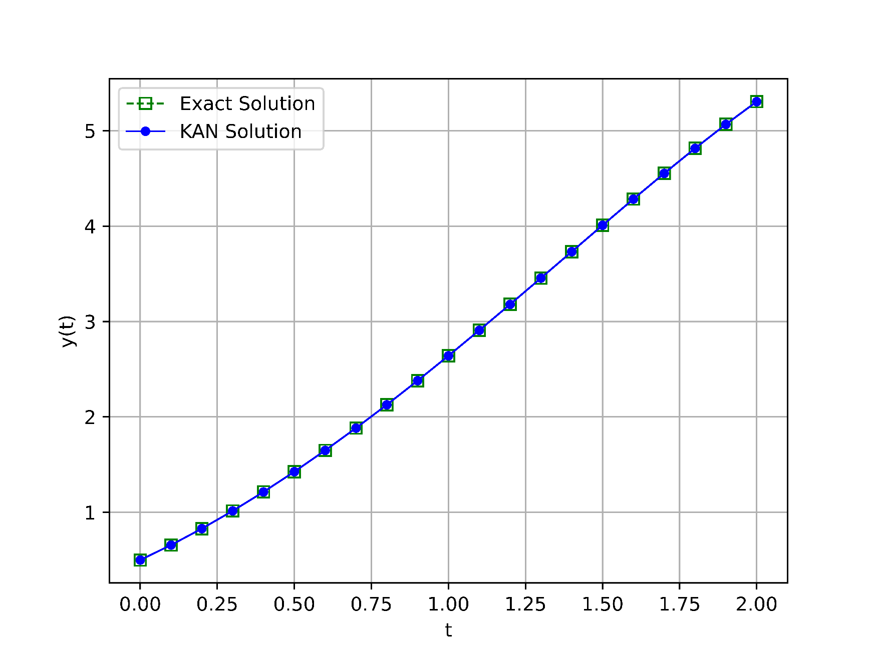**

Figure 3. Exact and KAN Solution Comparison for Example 3

1. **Conclusion**

In this study, the Kolmogorov-Arnold Network (KAN) was explored as a novel approach for approximating solutions to first-order Ordinary Differential Equations (ODEs). The KAN model, leveraging the Kolmogorov-Arnold theorem, successfully decomposes complex multivariate functions into simpler univariate components, enabling highly efficient and accurate function approximation. The results obtained from the numerical examples demonstrate that the KAN model outperforms traditional numerical methods, as well as other neural network models such as RBFNNs and WNNs, in terms of accuracy, convergence speed, and computational efficiency. With a significantly lower Mean Squared Error (MSE) across all test cases, KAN showcases its potential as a robust and reliable tool for solving ODEs. The study highlights the advantages of KAN's ability to approximate intricate mathematical models while maintaining minimal computational overhead. As neural network-based approaches continue to evolve, the KAN model holds promise as a leading method in the field of computational mathematics for resolving ODEs and other complex scientific problems. Future research may focus on further optimization techniques and extending KAN's application to more complex higher-order differential equations.

**CRediT authorship contribution statement (Change info below if needed)**

Morteza Farroknejad: Writing – review & editing, Writing – original draft, Methodology, Formal analysis, Data curation, Conceptualization.

Ali Farrokhnejad: Conceptualization. Writing – review & editing, Resources, Methodology, Formal analysis.

Ahmet Rizaner: Supervision, Conceptualization. Writing – review & editing, Writing – original draft, Resources, Project administration, Funding acquisition, Formal analysis, Data curation.

**Declaration of Competing Interest**

The authors declare that they have no known competing financial interests or personal relationships that could have appeared to influence the work reported in this paper.

**Data Availability**

No data was used for the research described in the article.

**Declaration of generative AI and AI-assisted technologies in the writing process.**

 During the preparation of this work the authors used Ref-n-Write and GPT-4o in order to improve the readability and language of the manuscript. After using these tools, the authors reviewed and edited the content as needed and take full responsibility for the content of this article.

**Acknowledgements (if there are any)**

**References (APA for now unless we decide to change it.)**

1. Tan, L. S., Zainuddin, Z., Ong, P., & Abdullah, F. A. (2024). An effective wavelet neural network approach for solving first and second order ordinary differential equations. *Applied Soft Computing*, *154*, 111328, <https://doi.org/10.1016/j.asoc.2024.111328>
2. Liu, M., Peng, W., Hou, M., & Tian, Z. (2023). Radial basis function neural network with extreme learning machine algorithm for solving ordinary differential equations. *Soft Computing*, *27*(7), 3955-3964, <https://doi.org/10.1007/s00500-022-07529-3>
3. Rizaner, F. B., & Rizaner, A. (2018). Approximate solutions of initial value problems for ordinary differential equations using radial basis function networks. *Neural Processing Letters*, *48*, 1063-1071, <https://doi.org/10.1007/s11063-017-9761-9>
4. Dwivedi, V., & Srinivasan, B. (2020). Physics informed extreme learning machine (pielm)–a rapid method for the numerical solution of partial differential equations. *Neurocomputing*, *391*, 96-118, <https://doi.org/10.1016/j.neucom.2019.12.099>
5. Li, S., & Wang, X. (2021). Solving ordinary differential equations using an optimization technique based on training improved artificial neural networks. *Soft Computing*, *25*(5), 3713-3723, <https://doi.org/10.1007/s00500-020-05401-w>
6. Kich, V. A., Bottega, J. A., Steinmetz, R., Grando, R. B., Yorozu, A., & Ohya, A. (2024, October). Kolmogorov-Arnold Networks for Online Reinforcement Learning. In *2024 24th International Conference on Control, Automation and Systems (ICCAS)* (pp. 958-963). IEEE.
7. Yu, T., Qiu, J., Yang, J., & Oseledets, I. (2024). Sinc kolmogorov-arnold network and its applications on physics-informed neural networks. *arXiv preprint arXiv:2410.04096*.
8. Jahin, M. A., Masud, M. A., Mridha, M. F., Aung, Z., & Dey, N. (2024). Kacq-dcnn: Uncertainty-aware interpretable kolmogorov-arnold classical-quantum dual-channel neural network for heart disease detection. *arXiv preprint arXiv:2410.07446*.
9. Liu, F., Viano, L., & Cevher, V. (2022). Understanding deep neural function approximation in reinforcement learning via $\epsilon $-greedy exploration. *Advances in Neural Information Processing Systems*, *35*, 5093-5108.
10. Heinlein, A., Klawonn, A., Lanser, M., & Weber, J. (2021). Combining machine learning and domain decomposition methods for the solution of partial differential equations—A review. *GAMM‐Mitteilungen*, *44*(1), e202100001, <https://doi.org/10.1002/gamm.202100001>
11. Goswami, S., Kontolati, K., Shields, M. D., & Karniadakis, G. E. (2022). Deep transfer operator learning for partial differential equations under conditional shift. *Nature Machine Intelligence*, *4*(12), 1155-1164.
12. Soleymani, F., & Zhu, S. (2021). RBF-FD solution for a financial partial-integro differential equation utilizing the generalized multiquadric function. *Computers & Mathematics with Applications*, *82*, 161-178, <https://doi.org/10.1016/j.camwa.2020.11.010>
13. Koenig, B. C., Kim, S., & Deng, S. (2024). KAN-ODEs: Kolmogorov–Arnold network ordinary differential equations for learning dynamical systems and hidden physics. *Computer Methods in Applied Mechanics and Engineering*, *432*, 117397, <https://doi.org/10.1016/j.cma.2024.117397>
14. Chen, Y., Yu, H., Meng, X., Xie, X., Hou, M., & Chevallier, J. (2021). Numerical solving of the generalized Black-Scholes differential equation using Laguerre neural network. *Digital Signal Processing*, *112*, 103003, <https://doi.org/10.1016/j.dsp.2021.103003>
15. Selitskiy, S. (2022). Kolmogorov's Gate Non-linearity as a Step toward Much Smaller Artificial Neural Networks. In *ICEIS (1)* (pp. 492-499), DOI: 10.5220/0011060700003179
16. van Deventer, H., van Rensburg, P. J., & Bosman, A. (2022). KASAM: Spline Additive Models for Function Approximation. *arXiv preprint arXiv:2205.06376*.
17. Shukla, K., Toscano, J. D., Wang, Z., Zou, Z., & Karniadakis, G. E. (2024). A comprehensive and FAIR comparison between MLP and KAN representations for differential equations and operator networks. *arXiv preprint arXiv:2406.02917*.
18. Liu, Z., Wang, Y., Vaidya, S., Ruehle, F., Halverson, J., Soljačić, M., Hou, T.Y. & Tegmark, M. (2024). Kan: Kolmogorov-arnold networks. *arXiv preprint arXiv:2404.19756*.
19. Haweel, T. I., & Abdelhameed, T. N. (2015, February). Power series neural network solution for ordinary differential equations with initial conditions. In *2015 International Conference on Communications, Signal Processing, and their Applications (ICCSPA'15)* (pp. 1-5). IEEE.
20. Sabir, Z., Wahab, H. A., Umar, M., Sakar, M. G., & Raja, M. A. Z. (2020). Novel design of Morlet wavelet neural network for solving second order Lane–Emden equation. *Mathematics and Computers in Simulation*, *172*, 1-14, <https://doi.org/10.1016/j.matcom.2020.01.005>